SET AUTOCOMMIT

📌 What is AUTOCOMMIT?
# Source: AI Source: Provided by: [Data Path: Persons Table -> ID Column: 1, Name_En Column: Motasem Essam] -> From: [ChatGPT] on [6/11/2026]
In MySQL, autocommit controls whether changes to the database are automatically saved (committed) after each SQL statement.
- When AUTOCOMMIT = 1 (default):
Every SQL statement is automatically committed right after execution.
- When AUTOCOMMIT = 0:
You must explicitly run COMMIT to save changes — otherwise, you can ROLLBACK to undo them.
🛠️ Syntax
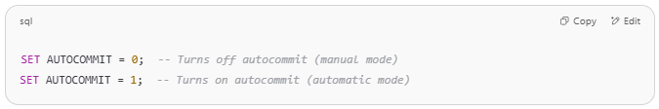
SET AUTOCOMMIT = 0; -- Turns off autocommit (manual mode)
SET AUTOCOMMIT = 1; -- Turns on autocommit (automatic mode)

🔄 Typical Use Case
# Source: AI Source: Provided by: [Data Path: Persons Table -> ID Column: 1, Name_En Column: Motasem Essam] -> From: [ChatGPT] on [6/11/2026]
You want to control when your changes are saved, especially if you're executing multiple statements that must all succeed together (or all fail).

✅ Example
# Source: AI Source: Provided by: [Data Path: Persons Table -> ID Column: 1, Name_En Column: Motasem Essam] -> From: [ChatGPT] on [6/11/2026]
Let’s simulate a safe transaction:
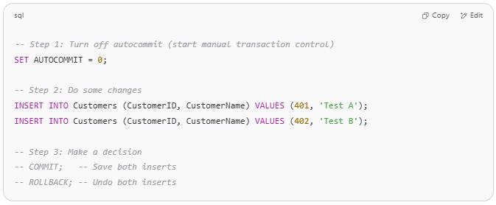
-- Step 1: Turn off autocommit (start manual transaction control)
SET AUTOCOMMIT = 0;

-- Step 2: Do some changes
INSERT INTO Customers (CustomerID, CustomerName) VALUES (401, 'Test A');
INSERT INTO Customers (CustomerID, CustomerName) VALUES (402, 'Test B');

-- Step 3: Make a decision
-- COMMIT; -- Save both inserts
-- ROLLBACK; -- Undo both inserts

⚠️ Until you run COMMIT, the inserted rows are only visible to your current session.

🧪 Verifying AUTOCOMMIT
# Source: AI Source: Provided by: [Data Path: Persons Table -> ID Column: 1, Name_En Column: Motasem Essam] -> From: [ChatGPT] on [6/11/2026]
To check current autocommit setting:
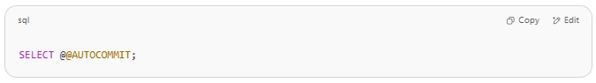
SELECT @@AUTOCOMMIT;

Returns:
- 1 → autocommit is on
- 0 → autocommit is off

❗ Important Notes
# Source: AI Source: Provided by: [Data Path: Persons Table -> ID Column: 1, Name_En Column: Motasem Essam] -> From: [ChatGPT] on [6/11/2026]
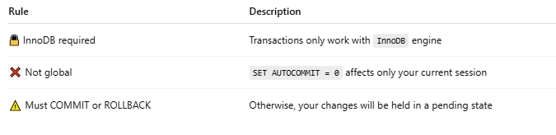
Rule | Description
🔒 InnoDB required | Transactions only work with InnoDB engine
❌ Not global | SET AUTOCOMMIT = 0 affects only your current session
⚠️ Must COMMIT or ROLLBACK | Otherwise, your changes will be held in a pending state

🧹 Optional Cleanup (Reset)
# Source: AI Source: Provided by: [Data Path: Persons Table -> ID Column: 1, Name_En Column: Motasem Essam] -> From: [ChatGPT] on [6/11/2026]
If you want to return to default behavior:
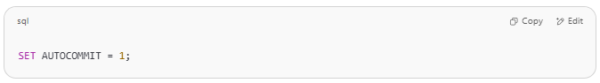
SET AUTOCOMMIT = 1;

✅ Step-by-step SQL Script
# Source: AI Source: Provided by: [Data Path: Persons Table -> ID Column: 1, Name_En Column: Motasem Essam] -> From: [ChatGPT] on [6/11/2026]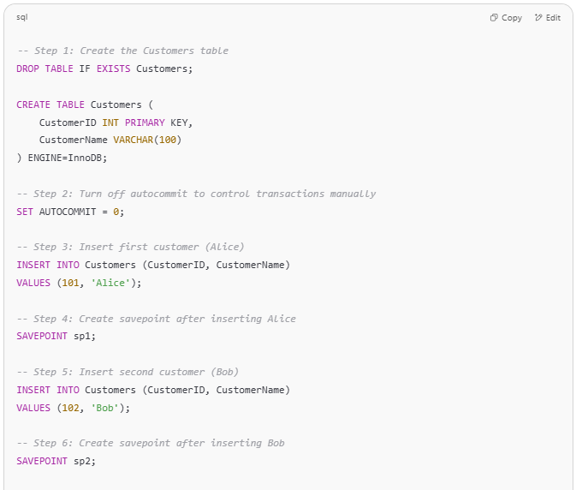
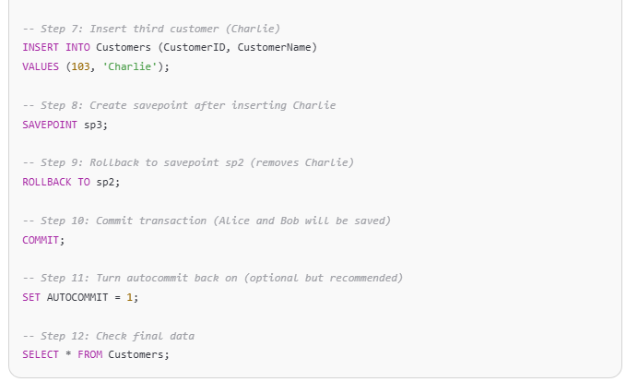
-- Step 1: Create the Customers table
DROP TABLE IF EXISTS Customers;

CREATE TABLE Customers (
CustomerID INT PRIMARY KEY,
CustomerName VARCHAR(100)
) ENGINE=InnoDB;

-- Step 2: Turn off autocommit to control transactions manually
SET AUTOCOMMIT = 0;

-- Step 3: Insert first customer (Alice)
INSERT INTO Customers (CustomerID, CustomerName)
VALUES (101, 'Alice');

-- Step 4: Create savepoint after inserting Alice
SAVEPOINT sp1;

-- Step 5: Insert second customer (Bob)
INSERT INTO Customers (CustomerID, CustomerName)
VALUES (102, 'Bob');

-- Step 6: Create savepoint after inserting Bob
SAVEPOINT sp2;

-- Step 7: Insert third customer (Charlie)
INSERT INTO Customers (CustomerID, CustomerName)
VALUES (103, 'Charlie');

-- Step 8: Create savepoint after inserting Charlie
SAVEPOINT sp3;

-- Step 9: Rollback to savepoint sp2 (removes Charlie)
ROLLBACK TO sp2;

-- Step 10: Commit transaction (Alice and Bob will be saved)
COMMIT;

-- Step 11: Turn autocommit back on (optional but recommended)
SET AUTOCOMMIT = 1;

-- Step 12: Check final data
SELECT * FROM Customers;

🧾 Expected Output (after the SELECT):
# Source: AI Source: Provided by: [Data Path: Persons Table -> ID Column: 1, Name_En Column: Motasem Essam] -> From: [ChatGPT] on [6/11/2026]
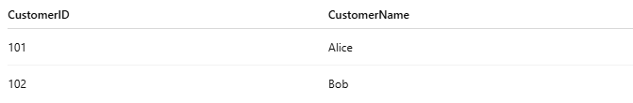

CustomerID | CustomerName
101 | Alice
102 | Bob

✅ Charlie is not included because we rolled back to the savepoint before his insert.

Example

prepared commands
# Source: ScreenShot Source: Provided by: [Persons Table -> ID Column: 1, Name_En Column: Motasem Essam] -> Tool: [Automation Table -> ID Column: 16, Name_En Column: Screen Capture] -> From [Operating System: Wampserver64 -> phpmyadmin] on [6/11/2026]
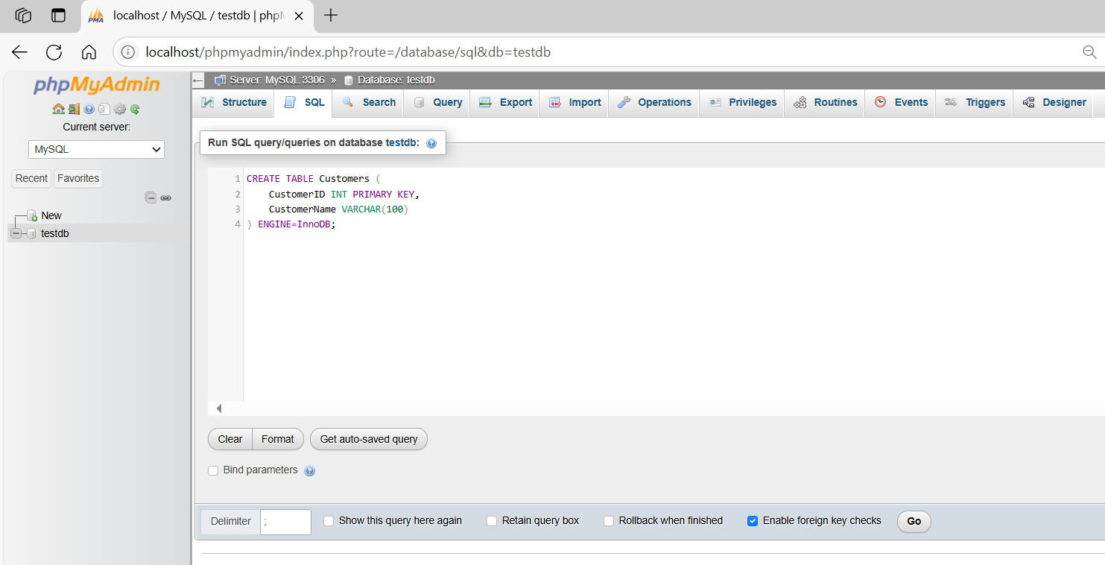
CREATE TABLE Customers (
CustomerID INT PRIMARY KEY,
CustomerName VARCHAR(100)
) ENGINE=InnoDB;
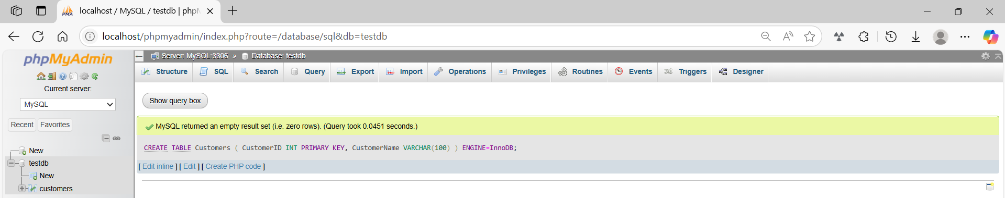

basic command
# Source: ScreenShot Source: Provided by: [Persons Table -> ID Column: 1, Name_En Column: Motasem Essam] -> Tool: [Automation Table -> ID Column: 16, Name_En Column: Screen Capture] -> From [Operating System: Wampserver64 -> phpmyadmin] on [6/11/2026]
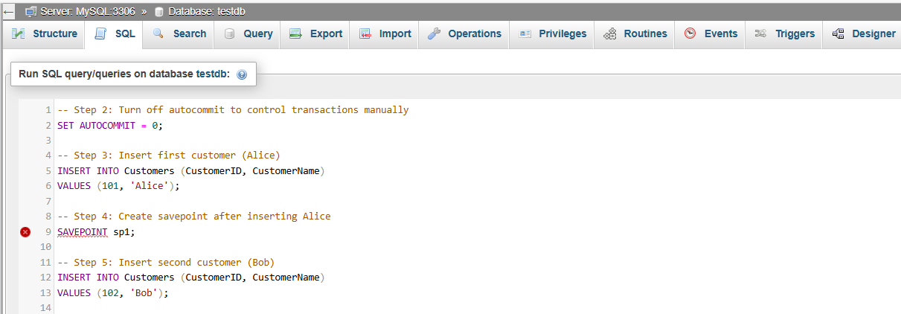
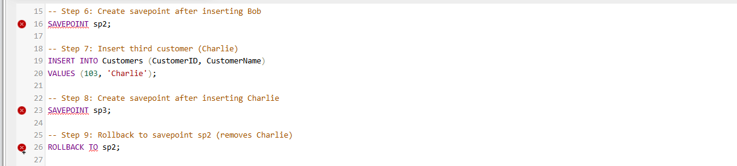
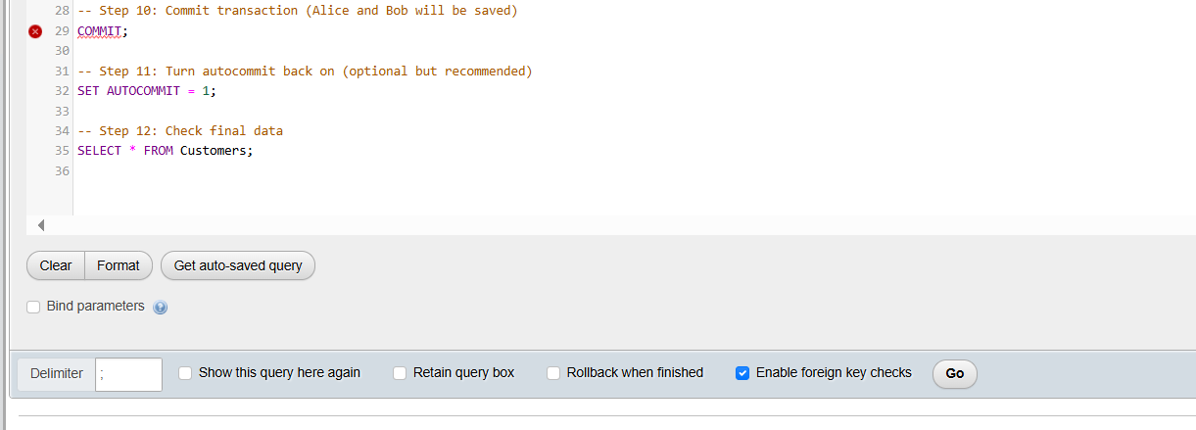
-- Step 2: Turn off autocommit to control transactions manually
SET AUTOCOMMIT = 0;

-- Step 3: Insert first customer (Alice)
INSERT INTO Customers (CustomerID, CustomerName)
VALUES (101, 'Alice');

-- Step 4: Create savepoint after inserting Alice
SAVEPOINT sp1;

-- Step 5: Insert second customer (Bob)
INSERT INTO Customers (CustomerID, CustomerName)
VALUES (102, 'Bob');

-- Step 6: Create savepoint after inserting Bob
SAVEPOINT sp2;

-- Step 7: Insert third customer (Charlie)
INSERT INTO Customers (CustomerID, CustomerName)
VALUES (103, 'Charlie');

-- Step 8: Create savepoint after inserting Charlie
SAVEPOINT sp3;

-- Step 9: Rollback to savepoint sp2 (removes Charlie)
ROLLBACK TO sp2;

-- Step 10: Commit transaction (Alice and Bob will be saved)
COMMIT;

-- Step 11: Turn autocommit back on (optional but recommended)
SET AUTOCOMMIT = 1;

-- Step 12: Check final data
SELECT * FROM Customers;

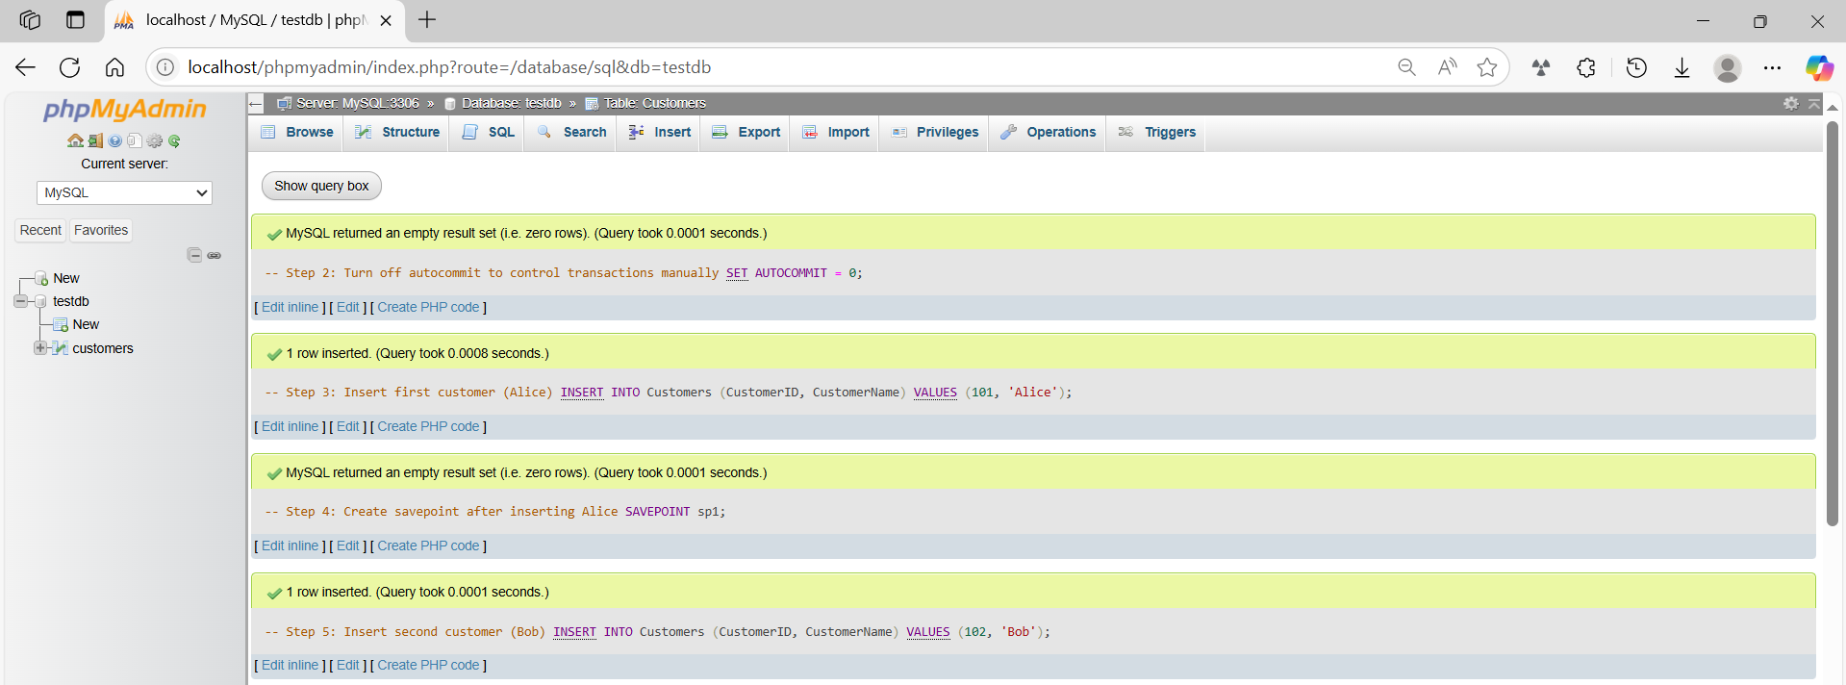
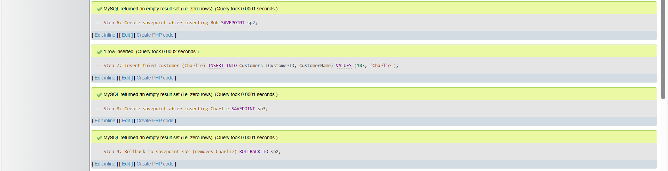
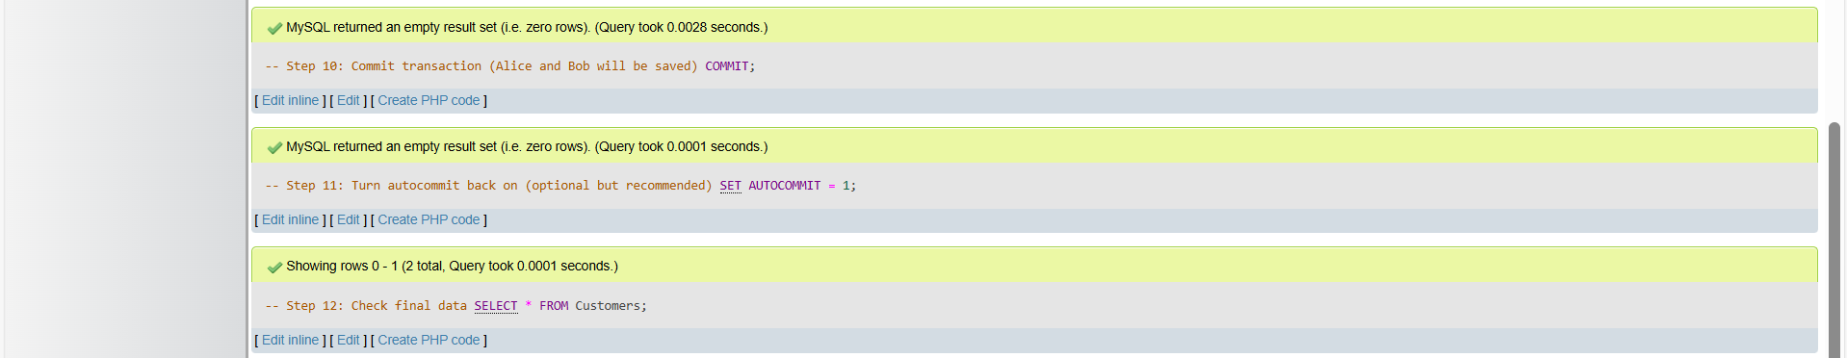
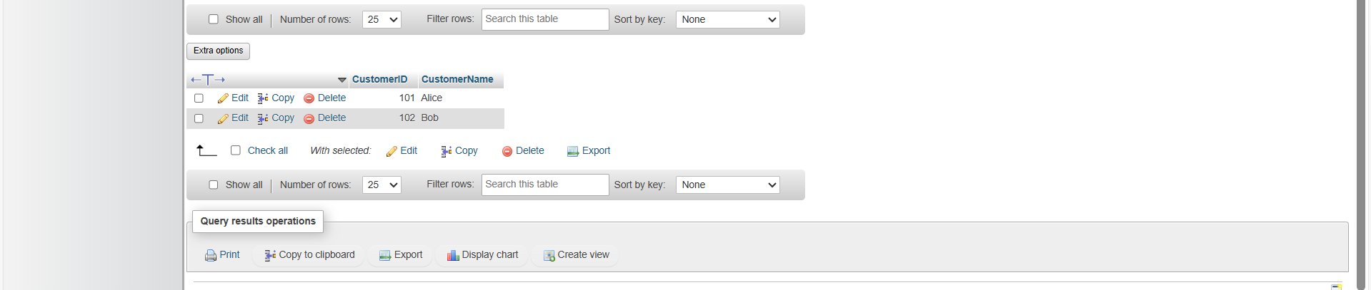

basic command
# Source: ScreenShot Source: Provided by: [Persons Table -> ID Column: 1, Name_En Column: Motasem Essam] -> Tool: [Automation Table -> ID Column: 16, Name_En Column: Screen Capture] -> From [Operating System: Wampserver64 -> phpmyadmin] on [6/11/2026]
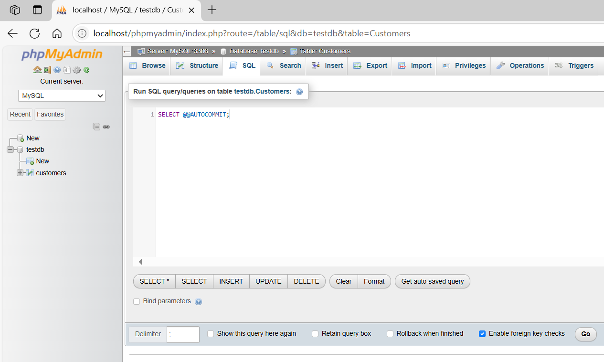
SELECT @@AUTOCOMMIT;
